Press release no. 1
INOUT 2025: FOR THREE DAYS, RIMINI HOSTS THE PREMIER SHOWCASE OF HOSPITALITY DESIGN, FURNISHINGS, AND TECHNOLOGIES
- Hospitality gathers at InOut | The Hospitality Community, at Rimini Expo Centre from 8-10 October: hotels, international chains, designers, contractors, and glamping and beach operators come together for three days of networking, trends, and business insights.

- Industry talks and discussions on beach tourism, new travel habits, the hospitality of the future, design, wellness, and digital innovation.
www.inout.it | www.ttgexpo.it
Rimini, 01 October 2025 – InOut | The Hospitality Community, the leading Italian B2B event dedicated to hospitality and the design of reception spaces, curated by Italian Exhibition Group, returns Rimini Expo Centre from October 8 to 10, coinciding with TTG Travel Experience. For three days, the expo centre will transform into a creative and strategic hub, with InOut occupying the East wing across 12 halls. Here, international hotels and chains, architects and interior designers, camping managers, and glamping and beach operators meet to explore trends, build relationships, and shape the industry’s future.
EXHIBIT AREAS
InOut 2025 guides visitors through eight exhibition areas, each dedicated to a key aspect of the hospitality world. It begins with Hotel Supplies (Hall D1), the vibrant hub offering solutions for rooms, reception, and common areas. Technologies and Services (Hall D1-D2) enable visitors to experience innovation through management software, home automation, and integrated systems. Pools and Spa – Poolwide area (Hall B1) features cutting-edge wellness and spa solutions, while outdoor tourism takes centre stage in Camping & Glamping (Hall. D7-B7) and Outdoor (Hall B3), with spaces dedicated to designing experiences in nature. There is no shortage of proposals for the Beach world (Hall D5-B5), offering the latest furnishings and equipment for beaches and resorts, and the Indoor Furniture area (Hall D3) highlighting trends and materials for interior spaces. Lastly, Sport & Entertainment (Hall D3-B2) completes the picture with solutions for fitness and recreational activities.
TWO ARENAS TO EXPLORE BEACH TOURISM, HOTELS, AND INNOVATION
Two dedicated arenas will provide a platform for deep dives on beach tourism and the hotel industry. The Beach Arena (Hall B5/D5) will focus on strategies for beach tourism, with in-depth insights into new customer habits, the future of concessions, the impact of climate change, and the industry’s economic prospects. The InOut Arena (Hall D3) will explore the new era of the hotel industry, including personalised guest experiences, integrating wellness and longevity, and the evolution of design and catering as an attraction driver. It will also highlight digital solutions and AI tools to simplify the management and marketing of accommodation facilities.

ABOUT TTG TRAVEL EXPERIENCE – INOUT | The Hospitality Community
Event: international trade show; organiser: Italian Exhibition Group SpA; frequency: annual; edition: 62nd; open to: trade only; website: www.ttgexpo.it www.inoutexpo.it

PRESS CONTACT IEG, TTG TRAVEL EXPERIENCE
Elisabetta Vitali, head of corporate communication & media relation; Marco Forcellini, Pier Francesco Bellini, press office manager
media@iegexpo.it
MEDIA AGENCY TTG TRAVEL EXPERIENCE
Martina Vacca: martina@mindthepop.it, mob. +39 339 748 5994; Fabrizio Raimondi: fabrizio@mindthepop.it, mob. +39 335 389 848; Benedetto Colli: benedetto@mindthepop.it, mob. 380 371 2272; Stefano Chiossi: stefano@mindthepop.it, mob. + 39 388 739 4358.

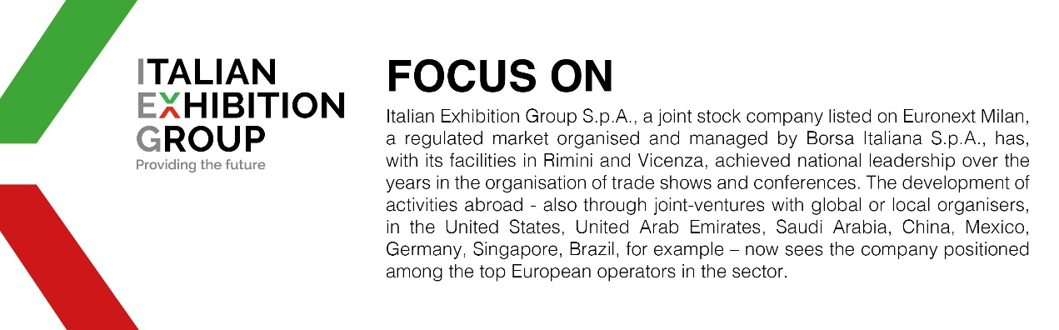

This press release contains forecast elements and estimates that reflect the management’s current opinions (“forward-looking statements”), particularly regarding future management performance, realization of investments, cash flow trends and the evolution of the financial structure. For their very nature, forward-looking statements have a component of risk and uncertainty, as they depend on the occurrence of future events. The effective results may differ (even significantly) from those announced, due to numerous factors, including, only by way of example: food service market and tourist flow trends in Italy, gold and jewellery market trends, green economy market trends; the evolution of raw material prices; general macroeconomic conditions; geopolitical factors and evolutions in the legislative framework. Moreover, the information contained in this release does not claim to be complete, and has not been verified by independent third parties. Forecasts, estimates and objectives contained herein are based on the information available to the Company as at the date of this release.

