Press release no. 2
INOUT 2025: SPECIAL PROJECTS, INSTALLATIONS, AND AWARDS NARRATE THE FUTURE OF HOSPITALITY
- InOut| The Hospitality Community, the Italian Exhibition Group's event scheduled at Rimini Expo Centre from October 8 to 10, features special projects and installations transforming the event into a journey through latest hospitality trends.
- Custom-designed rooms, cities envisioned by architects, and creative lounges create on-site immersive experiences.

www.inout.it | www.ttgexpo.it
Rimini, 01 October 2025 – InOut | The Hospitality Community, curated by Italian Exhibition Group lands at Rimini Expo Centre from October 8 to 10, and extends beyond the exhibition area to offer a series of special projects turning the visit into an immersive experience, with installations, visionary concepts, and creative spaces elevating the event.
Hall D3 will house Hotel in Motion, exploring the theme of the "Tailoring Experience," where the hotel becomes a narrative, with materials, lights, and pathways crafting a bespoke stay. Nearby, the Vision Lab invites visitors to travel through cities, seas, mountains, and countryside in four settings designed by international architecture firms. Meanwhile, in Hall D2, architect Simone Micheli presents a 200 m² luxury suite, a lounge area, and a bookstore, transforming the exhibition space into an immersive experience.
Art finds its expression in Artistic Tapestries, with suspended installations that interact with water and air in the outdoor pool area, while the Buyers Lounge serves as a workspace and networking hub for international buyers. Beach tourism professionals will discover the Beach Village as a central destination for modernising resorts and beaches, with the state-of-the-art equipment and interior solutions. Finally, architects and designers can expand their expertise and exchange insights in the Thinking Box area, featuring seminars and meetings dedicated to emerging hospitality concepts.
ABOUT TTG TRAVEL EXPERIENCE – INOUT | The Hospitality Community
Event: international trade show; organiser: Italian Exhibition Group SpA; frequency: annual; edition: 62nd; open to: trade only; website: www.ttgexpo.it www.inoutexpo.it
PRESS CONTACT IEG, TTG TRAVEL EXPERIENCE
Elisabetta Vitali, head of corporate communication & media relation; Marco Forcellini, Pier Francesco Bellini, press office manager
media@iegexpo.it
MEDIA AGENCY TTG TRAVEL EXPERIENCE
Martina Vacca: martina@mindthepop.it, mob. +39 339 748 5994; Fabrizio Raimondi: fabrizio@mindthepop.it, mob. +39 335 389 848; Benedetto Colli: benedetto@mindthepop.it, mob. 380 371 2272; Stefano Chiossi: stefano@mindthepop.it, mob. + 39 388 739 4358.
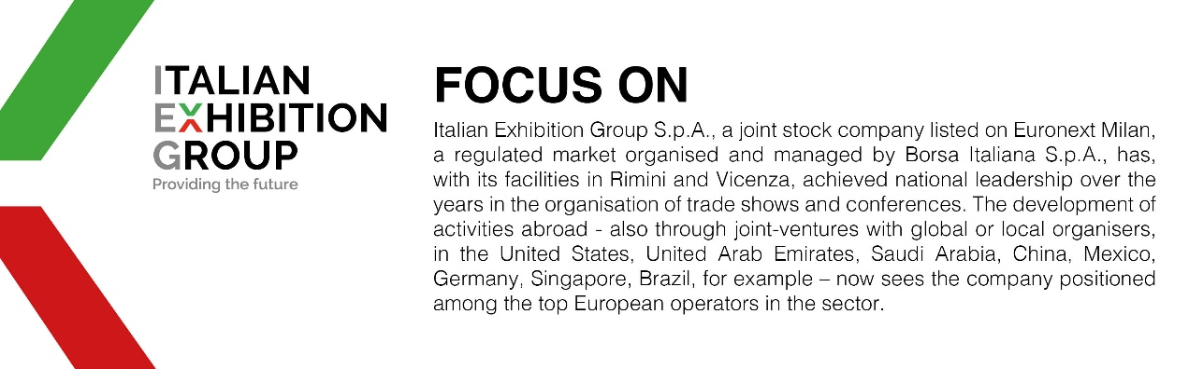

This press release contains forecast elements and estimates that reflect the management’s current opinions (“forward-looking statements”), particularly regarding future management performance, realization of investments, cash flow trends and the evolution of the financial structure. For their very nature, forward-looking statements have a component of risk and uncertainty, as they depend on the occurrence of future events. The effective results may differ (even significantly) from those announced, due to numerous factors, including, only by way of example: food service market and tourist flow trends in Italy, gold and jewellery market trends, green economy market trends; the evolution of raw material prices; general macroeconomic conditions; geopolitical factors and evolutions in the legislative framework. Moreover, the information contained in this release does not claim to be complete, and has not been verified by independent third parties. Forecasts, estimates and objectives contained herein are based on the information available to the Company as at the date of this release.

