Press release no. 3
INOUT 2025: THREE DAYS OF TALKS AND INSPIRATIONS FOR HOSPITALITY
- From October 8 to 10, the arenas of InOut | The Hospitality Community will spark lively discussions with over 30 events covering architecture, tourism, design, digital, and wellness. The programme weaves strategic visions and practical tools for hospitality industry professionals.

- Spotlight also on the awards: from the ADI InOut Hospitality Design Award 2025 to the Best Beach Award, and the Travel Food Award.
www.inout.it | www.ttgexpo.it
Rimini 01 October 2025 – From October 8 to 10, InOut | The Hospitality Community is not just an exhibition, it’s a platform for dialogue and vision: the two main arenas – InOut Arena (Hall D3) and Beach Arena (Hall B5/D5) – host a calendar of events that bring together architecture, tourism, design, digital, and wellness. Alongside these, other areas of the expo centre complete the programme with talks and awards dedicated to design, innovation, and emerging trends in hospitality.
NOT-TO-BE-MISSED EVENTS AT INOUT 2025
Wednesday, October 8
- “Smart Platforms for the New Era of Hospitality” (InOut Arena, 11:00–12:00): TITANKA! Group opens the discussion on digital solutions and automation to simplify bookings and enhance tourism marketing.
- “Beach Digitalisation Observatory 2025” (Italy Arena, 11:00–12:00): Spiagge.it presents data from the 2025 beach season, including bookings, average spending, and booking windows compared with the previous year.
- "Wellness and Longevity in Hotels" (InOut Arena, 1:20 PM – 2:20 PM): Technogym demonstrates how wellness can become a strategic driver for attracting and retaining guests.
- "Beach tourism in the new era" (Beach Arena, 1:20 PM – 2:20 PM): Visit Romagna and CISET explore habits, spending, and development strategies for the future of beach tourism.
- "Celebrating Spas" (InOut Arena, 2:30 PM – 3:30 PM): Alberto Apostoli discusses how spas are becoming the heart of the travel experience.
- "Tourism as an Artistic Act" (Global Village Arena, 2:30 PM – 3:30 PM): Michelangelo Pistoletto and the Cittadellarte Foundation present the "Third Paradise" and reflect on the connection between art and tourism.
- "New visions for the revival of hospitality" (InOut Arena, 3:40 PM – 4:40 PM): The University of Gastronomic Sciences in Pollenzo introduces a novel approach to hospitality, combining food, light, and music.
- "The New Era of Beach Concessions" (Beach Arena, 3:40 PM – 4:40 PM): FAITA-FederCamping and CISET update the industry on regulations and upcoming concession tenders.
- "Measuring the Tourism of the New Era" (InOut Arena, 4:50 PM – 6:00 PM): CISET and its open-air partners present analytical tools to optimise planning for the 2025 season.

Thursday October 9
- "Are hotels still a home away from home?" (InOut Arena, 11:00 – 12:00): Internationally renowned architects and designers reflect on hospitality, exploring the interplay between ethics, aesthetics, and function.
- "Tourist destinations of the new era" (Beach Arena, 11:00 – 12:00): Visit Romagna discusses how digital technology is guiding travellers through increasingly integrated experiences.
- "Travel Food Award 2025" (InOut Arena, 12:00 – 13:00): GIST Italia celebrates voices in food as tools for dialogue and inclusion, recognising those who promote ethical and sustainable agri-food.
- "Awakening to Transformative Wellness" (InOut Arena, 12:10 – 13:10): SPA Consulting offers training and knowledge sharing to turn tourism into a regenerative experience.
- "Tourism Development and Urban Simplification" (InOut Arena, 1:20 PM – 2:20 PM): Assopiscine and FAITA-FederCamping discuss new growth strategies for regions and businesses.
- "Beaches 2035" (Beach Arena, 2:30 PM – 3:30 PM): Mondo Balneare addresses climate change and strategies for a sustainable future of the coasts.
- ADI InOut Hospitality Design Award 2025 (Design Arena, 2:30-3:30 PM): The event, now in its second edition, awards the best projects showcasing innovative design solutions for the hospitality industry.
- "Youth Tourism: The Next Frontier" (InOut Arena, 3:40 PM – 4:40 PM): Federalberghi and CNGA explore ways to address the needs and aspirations of the new generations.
- "Open Air & Sport Tourism" (InOut Arena, 4:50 PM – 6:00 PM): FAITA-FederCamping and Assosport bring together outdoor operators and sports brands to create new market synergies.
- "Best Beach Award" (Beach Arena, 4:20 PM – 5:20 PM): Mondo Balneare celebrates Italy's most innovative and welcoming beaches in the tenth edition of the award.
Friday, October 10
- "Artificial Intelligence and Automation for the Hotel Industry" (InOut Arena, 11:00 – 12:00): The TITANKA! Group presents the new digital frontiers to make marketing, management, and bookings smarter.
- "The double challenge of the beach industry" (Beach Arena, 11:00 – 12:00): FAITA-FederCamping and Mondo Balneare analyse safety, tenders, and compensation to prepare for the future of concessions.
- "Awakening Hospitality" (InOut Arena, 12:10 – 13:10): Federalberghi presents guidelines and solutions to provide a more personalised and memorable guest experience.

ABOUT TTG TRAVEL EXPERIENCE – INOUT | The Hospitality Community
Event: international trade show; organiser: Italian Exhibition Group SpA; frequency: annual; edition: 62nd; open to: trade only; website: www.ttgexpo.it www.inoutexpo.it

PRESS CONTACT IEG, TTG TRAVEL EXPERIENCE
Elisabetta Vitali, head of corporate communication & media relation; Marco Forcellini, Pier Francesco Bellini, press office manager
media@iegexpo.it
MEDIA AGENCY TTG TRAVEL EXPERIENCE
Martina Vacca: martina@mindthepop.it, mob. +39 339 748 5994; Fabrizio Raimondi: fabrizio@mindthepop.it, mob. +39 335 389 848; Benedetto Colli: benedetto@mindthepop.it, mob. 380 371 2272; Stefano Chiossi: stefano@mindthepop.it, mob. + 39 388 739 4358.

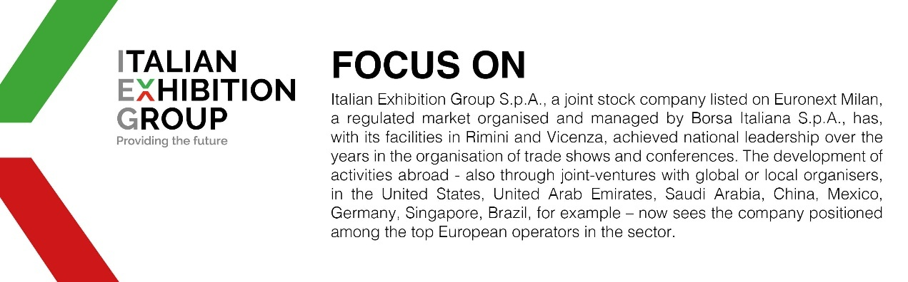

This press release contains forecast elements and estimates that reflect the management’s current opinions (“forward-looking statements”), particularly regarding future management performance, realization of investments, cash flow trends and the evolution of the financial structure. For their very nature, forward-looking statements have a component of risk and uncertainty, as they depend on the occurrence of future events. The effective results may differ (even significantly) from those announced, due to numerous factors, including, only by way of example: food service market and tourist flow trends in Italy, gold and jewellery market trends, green economy market trends; the evolution of raw material prices; general macroeconomic conditions; geopolitical factors and evolutions in the legislative framework. Moreover, the information contained in this release does not claim to be complete, and has not been verified by independent third parties. Forecasts, estimates and objectives contained herein are based on the information available to the Company as at the date of this release.

