Press release no. 4
INOUT LAYOUT
www.inout.it | www.ttgexpo.it
Rimini, 01 October 2025 –The layout of InOut|The Hospitality Community (Rimini Expo Centre, October 8-10, 2025) joins that of TTG Travel Experience, both events curated by Italian Exhibition Group.
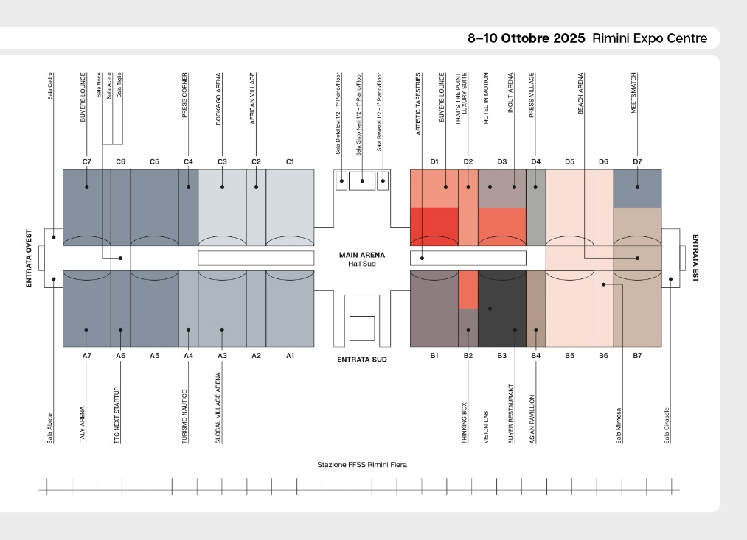

InOut|The Hospitality Community will occupy the East wing of Rimini Expo Centre, featuring 12 dedicated halls. Access from either the South entrance, through the Main Arena that separates InOut from TTG Travel Experience, or from the East entrance, directly facing the Beach Village and its Beach Arena.

The eight exhibition areas are organised as follows:

- Hotel Supplies (Hall D1)
- Technologies and Services (Hall D1 – D2)
- Sport & Entertainment (Hall D3 – B2)
- Pools and Wellness (Hall B1– Poolwide)
- Camping & Glamping (Halls D7 – B7 – Hall B7/D7)
- Beach sector (Halls D5 – B5 – Hall B5/D5)
- Indoor Design & Furnishings (Hall D3)
- Outdoor Design & Furnishings (Hall B3)
This edition’s special projects include Hotel in Motion in Hall D3 designed by architect Anna Palucci for FAI LA COSA GIUSTA (W7.0 – Wellnessettepuntozero), brings to life an innovative concept of hospitality in motion. Next door in Hall B3, Vision Lab takes visitors on a journey across city, sea, mountains and countryside, through four immersive 640 m² settings created by leading architecture firms ATI Project, Lombardini22, Progetto CMR and Studio Marco Piva.
Hall D2 hosts THAT's the POINT | luxury suite, a new creation by Simone Micheli with a visual identity by Roberta Colla. This 900 m² space has been transformed into a scenic ensemble featuring luxury suites, a lounge area, and a museum bookstore. Art finds its expression in Artistic Tapestries, an installation curated by Cinquerosso Arte in the outdoor pool area, featuring suspended works, suspended between water and air, change shape and colour, interpreting the theme "Awake."
Designed for international buyers, the Buyers Lounge space by Studio Cappelletti+Fumagalli will be located in Hall D1. Beach Village, created in partnership with Mondo Balneare, is dedicated to beach tourism. It serves as a hub for resort managers, entrepreneurs, and designers to discover furnishing solutions and technologies for upgrading beach resorts and outdoor spaces. Finally, in Hall B2 will house Thinking Box, a space organised in collaboration with the Order of Architects of Rimini, accommodating up to 600 professionals and offering accredited seminars focused on new hospitality concepts.
The Arenas
Dialogue in the InOut | The Hospitality Community primarily takes shape in the two main arenas. The Beach Arena, set up in Hall B5/D5, will serve as the stage for exchanges focused on the new era of beach tourism. It will offer a privileged view of customer habits, their spending tendencies, and the strategies that will shape the future of the industry. The InOut Arena, located in Hall D3, is the place where hospitality is transformed into vision and inspiration, hosting intelligent platforms for more effective hotel marketing, the technologies revolutionising the hotel industry, wellness as a new frontier in travel experiences, and the role of dining, which is a growing driver of destination appeal.

ABOUT TTG TRAVEL EXPERIENCE – INOUT | The Hospitality Community
Event: international trade show; organiser: Italian Exhibition Group SpA; frequency: annual; edition: 62nd; open to: trade only; website: www.ttgexpo.it www.inoutexpo.it

PRESS CONTACT IEG, TTG TRAVEL EXPERIENCE
Elisabetta Vitali, head of corporate communication & media relation; Marco Forcellini, Pier Francesco Bellini, press office manager
media@iegexpo.it
MEDIA AGENCY TTG TRAVEL EXPERIENCE
Martina Vacca: martina@mindthepop.it, mob. +39 339 748 5994; Fabrizio Raimondi: fabrizio@mindthepop.it, mob. +39 335 389 848; Benedetto Colli: benedetto@mindthepop.it, mob. 380 371 2272; Stefano Chiossi: stefano@mindthepop.it, mob. + 39 388 739 4358.

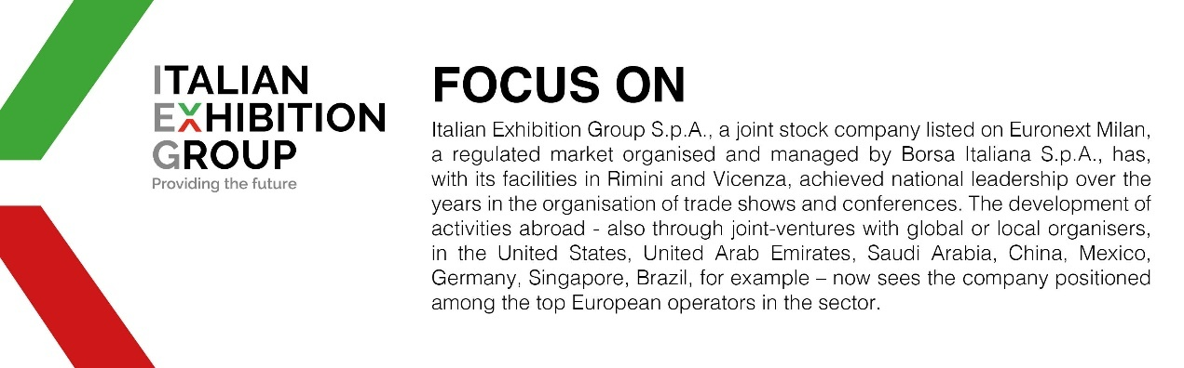

This press release contains forecast elements and estimates that reflect the management’s current opinions (“forward-looking statements”), particularly regarding future management performance, realization of investments, cash flow trends and the evolution of the financial structure. For their very nature, forward-looking statements have a component of risk and uncertainty, as they depend on the occurrence of future events. The effective results may differ (even significantly) from those announced, due to numerous factors, including, only by way of example: food service market and tourist flow trends in Italy, gold and jewellery market trends, green economy market trends; the evolution of raw material prices; general macroeconomic conditions; geopolitical factors and evolutions in the legislative framework. Moreover, the information contained in this release does not claim to be complete, and has not been verified by independent third parties. Forecasts, estimates and objectives contained herein are based on the information available to the Company as at the date of this release.

