Press release no. 5
TTG TRAVEL EXPERIENCE | INOUT THE HOSPITALITY COMMUNITY 2025
SERVICE GUIDE
www.ttgexpo.it | www.inout.it
Getting to the Rimini Fair and staying in the Rimini area is much easier with the services designed for operators and visitors of TTG Travel Experience and InOut|The Hospitality Community, both organized simultaneously by Italian Exhibition Group from October 8 to 10, 2025.
► ENTRANCE TO THE EXPO CENTRE: access from three entrances:
- SOUTH: Via Emilia 155, directly connected to the "Riminifiera" train station
- EAST: Via Costantino il Grande
- WEST: Via San Martino in Riparotta
► OPENING HOURS: Wednesday and Thursday: 10:00 am – 6:00 pm; Friday: 10:00 am – 5:00 pm
►TICKETS: This is a B2B trade fair. To access the reserved visitors’ area and ticketing section, registration is required via this link: https://www.ttgexpo.it/visita/reserved-area
►REDUCED MOBILITY ACCESS: Rimini Expo Centre provides easy access and convenient use for people with disabilities, offering the following services: reserved parking, step-free entrances accessible via ramps, push-to-open doors, single-level halls all directly connected, spacious refreshment areas allowing freedom of movement, appropriately equipped restrooms, conference rooms on the upper floor with lift access, a train station on the Milan-Bari line with lift access, and mobility aids (manual wheelchairs) that can be booked for the event days. Rimini Expo Centre offers free mobility aids (wheelchairs) to users on event days, available upon reservation. To submit your reservation, download the form here, and send it to our HELPDESK (helpdesk.rn@iegexpo.it).
► SPECIAL TRAINS: During the event, trains stop at Riminifiera station, situated at just 50 meters from the South entrance. Here you can download the timetables for Frecce, Regionali, and Intercity trains. Get real-time updates on the Trenitalia website (www.trenitalia.com) by entering ‘Riminifiera’ station as your destination.
Thanks to the agreement between Italian Exhibition Group and Trenitalia, visitors benefit from a "Special Events" offer, enjoying discounts of up to 75% on Frecciarossa, Frecciargento, and Frecciabianca tickets, and up to 80% on Intercity and Intercity Night tickets, across all classes and service levels.
The offer applies to trips to or from Rimini or Riminifiera, starting from the second day before the event and ending the day after closure. Tickets can be purchased via the Trenitalia App, ticket offices, authorised agencies, or on trenitalia.com (up to 5 days before departure for Frecce and 2 days for Intercity).
► ROAD ROUTES, CAR RENTAL AND TAXIS: Rimini Expo Centre is connected to the A14, the Bologna-Bari-Taranto motorway, just 6 km from the Rimini Nord exit and 7 km from the Rimini Sud exit. For more information, visit: https://www.iegexpo.it/it/venues/rimini/quartiere. Taxi service at (+39) 0541/50.020. Electric car sharing with Corrente is available, which can be booked via the app, or you can rent a car with AVIS Car Rental (https://www.avisautonoleggio.it/).

► PARKING: the Expo Centre provides 11,000 paid parking spaces. Full details available here.
► PUBLIC TRANSPORT: the Expo Centre is well connected by a regular bus service. No. 9 (from the airport with a stop at Rimini train station), no. 9 bis (from Rimini train station without intermediate stops), and two other dedicated buses: no. 5 departing from San Mauro Mare and no. 10 departing from Miramare. More information: https://www.startromagna.it/servizi/orari-e-percorsi/
FREE shuttle buses during the event:
- AB: Rimini Marina Centro ⇄ Rimini Expo Centre
- D: Riccione ⇄ Rimini Expo Centre
- CE: Bellaria ⇄ Rimini Expo Centre
Arrival/departure point – South Entrance: timetables and routes

► BY AIR: Rimini Expo Centre is easily accessible from several airports, with direct connections and dedicated shuttle services.
- New for 2025: Direct flight Rome – Rimini
In collaboration with Luxwing, a direct flight will be available during the event.
Booking and schedules
Rimini “Federico Fellini” Airport ↔ Rimini Expo Centre
8km from the venue serviced by bus (no.9) and taxis. During TTG, dedicated shuttles are available for the Expo Centre.
Info on transport and shuttle service
Bologna “Guglielmo Marconi” Airport ↔ Rimini Expo Centre
Direct shuttle bus Bologna Airport ⇄ Rimini Expo Centre (South Entrance) during the event.
- Different timetables for round trips
- Price: €25 (online) – €30 (onboard or at airport desk)
- Advanced booking recommended
timetables and tickets here
Other nearby airports
- Forlì (50 km) – Bus and train connections to Rimini
- Ancona Falconara (90 km) – Direct train connections to Rimini
- Venice, Bergamo, Milan – Train connections with stops in Rimini or Riminifiera
Info and links here
► METROMARE: public transport system connecting the stations of Rimini and Riccione, passing through 15 intermediate stations. Daily trips every 20 minutes. Timetables here
► E-MICROMOBILITY: reach the venue by Lime and Bit Mobility e-scooters or e-bikes: download the app, register and unlock the vehicle by scanning the QR code; parking areas available at South entrance and West car parks 1-2; Special discount codes -> Lime: LIMEXFIERA; Bit Mobility: TTGBIT2025

ABOUT TTG TRAVEL EXPERIENCE – INOUT | The Hospitality Community
Event: international trade show; organiser: Italian Exhibition Group SpA; frequency: annual; edition: 62nd; open to: trade only; website: www.ttgexpo.it www.inoutexpo.it

PRESS CONTACT IEG, TTG TRAVEL EXPERIENCE
Elisabetta Vitali, head of corporate communication & media relation; Marco Forcellini, Pier Francesco Bellini, press office manager
media@iegexpo.it
MEDIA AGENCY TTG TRAVEL EXPERIENCE
Martina Vacca: martina@mindthepop.it, mob. +39 339 748 5994; Fabrizio Raimondi: fabrizio@mindthepop.it, mob. +39 335 389 848; Benedetto Colli: benedetto@mindthepop.it, mob. 380 371 2272; Stefano Chiossi: stefano@mindthepop.it, mob. + 39 388 739 4358.

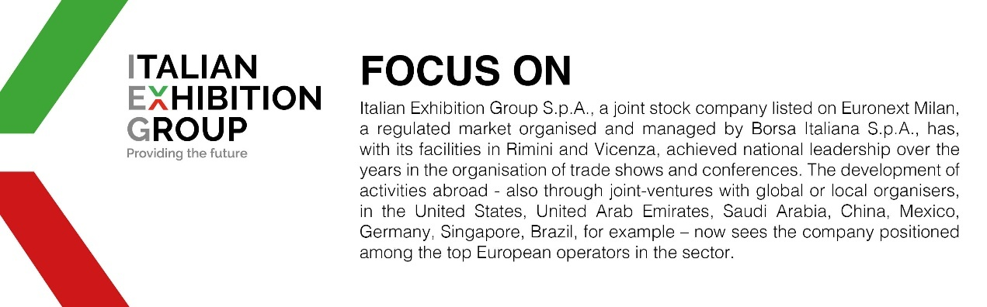

This press release contains forecast elements and estimates that reflect the management’s current opinions (“forward-looking statements”), particularly regarding future management performance, realization of investments, cash flow trends and the evolution of the financial structure. For their very nature, forward-looking statements have a component of risk and uncertainty, as they depend on the occurrence of future events. The effective results may differ (even significantly) from those announced, due to numerous factors, including, only by way of example: food service market and tourist flow trends in Italy, gold and jewellery market trends, green economy market trends; the evolution of raw material prices; general macroeconomic conditions; geopolitical factors and evolutions in the legislative framework. Moreover, the information contained in this release does not claim to be complete, and has not been verified by independent third parties. Forecasts, estimates and objectives contained herein are based on the information available to the Company as at the date of this release.

